March 21, 2022
American Saddlebred Breeder’s Futurity of the Carolinas, Inc.  A 501(c)(3) Corporation  www.carolinasfuturity.com  Annette Greene, Secretary: 1498 Rom Eller Road; Ferguson, NC 28624-9092  Cell, 336.984.6321 / greeneann@hotmail.com | 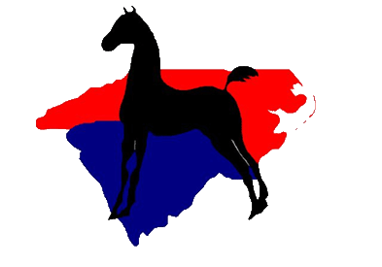
Sheila Wingler, President: Cell, 336.469.5415
Showing Tomorrows’ Champions Today

Dear Saddlebred Enthusiast:
Do you have 2022 foals you want to nominate to the Carolinas’ Futurity? We certainly hope so! It’s time to make new and if necessary renew existing nominations to The Carolinas’ Futurity. Please review all information in this letter, as well as the information on the 2022 forms which are attached. Feel free to share this information with any Saddlebred owner who has 2022 foals.
Everyone needs to legibly fill in the owner/agent contact information on page 1. No prize monies will be awarded without a Social Security number for the payee.
If you bought a 2021 stallion service from the Carolinas’ Futurity or bred to a stallion who sold at the Futurity, nominate your foal by completing the appropriate weanling nomination form. You must fill in the sire’s name and registration number, but you do not owe a stallion nomination fee, saving you $ 75. The mare and foal nomination fee for the weanling year only is $ 75 (Use page 1). Foals nominated for the weanling year only must be renewed annually to remain eligible for Futurity competition. If you want to nominate your foal past the weanling year, you may pay a fee of $150.00 for the foal’s weanling, yearling and 2-year old years OR $225.00 for the foal’s weanling, yearling, 2-year old, and 3-year old years (Use page 2).
If you did NOT buy your stallion service from the Carolinas’ Futurity, you must pay a $ 75.00 stallion nomination fee, in addition to the mare and weanling nomination fees of either $ 75, $ 150, or $ 225.
If you donated a stallion service to the 2021 Carolinas’ Futurity Auction and the service sold, you are allotted one free mare and foal nomination for the weanling year only. Use the Stallion Donor’s Nomination form.
If you purchased a foal or your foal was born after the June 15th deadline and you did not nominate it prior to birth, use the “Special Late Weanling Nomination” form.
I will check the records on file and send a separate e-mail to you regarding the status of previous nominations. If any have to be renewed, I will inform you. If you are good to go, I will inform you. Page 3 will be used for renewal nominations. However, I do make mistakes. I will make every effort to correct my errors with your help. It is best to contact me via the e-mail address above. I do NOT receive e-mails on my phone.
Remember: All 2022 nominated foals must be registered by December 31, 2022.
Please use the attached current forms when completing your 2022 nominations. Last year, the Carolinas’ Futurity awarded over $ 65 000.00 in the seven Futurity classes which are included in the UPHA Chapter 12 North Carolina State Championship Horse Show held in September in Raleigh. Don’t miss out!
Nominations and renewals must be postmarked by June 15, 2022, and mailed with payment to Annette Greene at the address above. Thank you for your support of the Carolinas’ Futurity.
Sincerely,
Annette Greene, Secretary

