May 15, 2018
The Carolinas’ Futurity  A 501(c)(3) Corporation  www.carolinasfuturity.com  Annette Greene, Secretary  1498 Rom Eller Road  Ferguson, NC 28624  Phone, 336.973.3956 / Cell, 336.984.6321 / greeneann@hotmail.com | 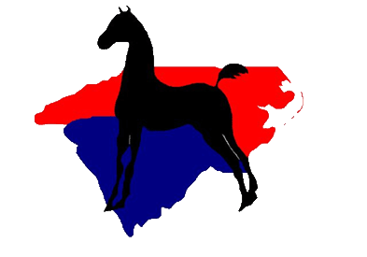
Showing Tomorrows’ Champions Today
Dear Mare Owner:
Enclosed are nomination forms for the Carolinas’ Futurity and a general information sheet about the Futurity. Nominations of 2018 foals are due on June 18, 2017. There are sections on the form for nominating foals to the Carolinas’ Futurity on a yearly basis or through the two-year old or three-year old years. There is also a form for weanling ’Special Late’ nominations. Owners of a foal purchased or born after the June 15 deadline may nominate the weanling to the Futurity. Weanlings nominated as a ‘Special Late’ nomination must be nominated through their three-year old year at a cost of $ 300 and are ineligible to show in their weanling year. The Futurity encourages the nomination of in-utero foals by June 15.
If you nominate foals for more than one owner, please use a separate form for each owner. Make certain the Social Security Number for the foal’s owner is included on the nomination form, as prize monies will not be paid out unless a social security number is on file. Nomination forms are available for completion or printing on our website www.carolinasfuturity.com.
It is also time to nominate yearlings and two-year olds if you are using the yearly nomination option. If you nominated your weanling through its two-year old or three-year old year, your nomination is complete and you do not need to send anything for the Futurity files.
If you sold a horse nominated to the Futurity, please notify the new owner of the horse’s eligibility status
When completing nominations for weanlings, remember that either the stallion owner OR the mare owner must nominate the stallion. Notify the stallion owner of your intent to nominate your weanling, as the stallion owner may be willing to nominate their stallion. Stallions purchased through the Carolinas’ Futurity silent or live auctions require no nomination payment, but their information must be completed on the form.
All foals must be nominated and have permanent or “conditional” registration papers on file with the American Saddlebred Registry to be eligible to show in the Futurity classes at the September North Carolina State Championship Charity Horse Show in September. Affidavits will not be accepted for Futurity Classes. Permanent papers must be issued by March 31st of the yearling year for continued eligibility and pay out of prize monies.
Please feel free to contact me if you have questions, or if I can help you in any way.

Annette Greene, Secretary

